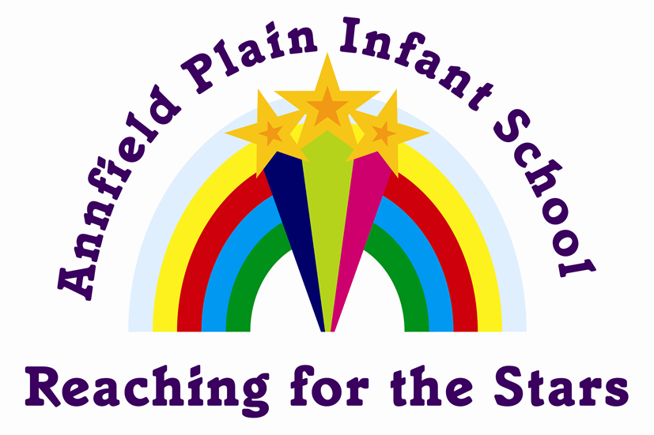

Parent Handbook | September  2022
Your step-by-step guide to your child starting school at Annfield Plain Infant School

Contents

- School Achievements
- Stanley Learning Partnership
- Ofsted Inspection
- School Organisation
- The School governors
- School Routine
- Arrangements for Admissions and Induction
- School Attendance
- School Holidays
- School Curriculum
- Parental support
- Special Educational Needs
- School travel Plan
- Homework
- Assessment, Recording and Reporting to Parents
- Home School and the Community
- What School Documents are made available
- Why I wont always come home ‘clean!’

Welcome

Dear Parents and Carers,
Welcome to Annfield Plain Infant School.
We hope that you enjoy browsing this brochure, and that it will give you a glimpse into life at our busy and exciting school. Its purpose is to give you all of the information you may need about our school, including the organisation and routines.
Our aim is to provide a caring community which is based on mutual trust and respect for the values and beliefs of others. We provide a safe and stimulating environment, which enables children to achieve their personal, creative and academic potential in order to become lifelong learners. We look forward to working in partnership with parents and extend a warm welcome to visit our school.
If you require further information on any of the items shown, please contact the school team and we will do our best to help you.
Yours sincerely,

Mrs A Kane Mrs S Scott
Headteacher Chair of Governors

Mr M Urwin
Deputy Headteacher

“A key strength of the school that has been maintained is the personal development and welfare of your pupils. From the very outset, children starting in the Reception class enter a caring, nurturing environment which helps them to develop their social skills and self-confidence. This continues as pupils get older.” Ofsted Oct 2018.

Our ethos & aims
Statement
The Governors aims for the school are:

· To promote the spiritual, cultural, mental and physical development of the children in school and in society.
· To prepare pupils for opportunities, responsibilities and experiences of adult life.

Aims
- · To develop a caring community in which concern and respect for others is fostered and the importance of good will, sensitivity and tolerance in interpersonal relationships is exemplified.
- · To recognise the needs and talents of each pupil and to facilitate the development of creative, intellectual, moral, physical and social capacity.
- · To ensure that the curriculum incorporates legislative requirements and is appropriate, flexible and relevant to each pupil.
- · To monitor in a systematic manner the progress of each individual and the work of the school.
- · To foster an awareness of social responsibility to the school and the local community and society at large, encouraging each individual to accept responsibilities and develop self-awareness and discipline.
- · To provide a caring, disciplined and supportive environment for each pupil and prepare each pupil for life beyond the school.

Stanley Learning Partnership

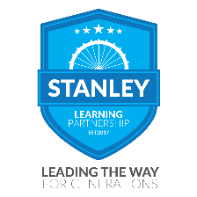
At the heart of our community of schools, is the belief that every child can achieve. We create an environment that allows children to develop their talents, both as individuals and a collective, empowering them to succeed in and outside of the classroom.
At every opportunity, we will encourage our children to contribute to the life and work of school, giving them a greater sense of belonging so they are best equipped to share, respect and trust in the start in life we offer them.
All schools within Stanley Learning Partnership share the desire to provide education excellence where children excel and aspire without limit. Irrespective of their ability or background, we are committed to providing inclusive learning. Via our rich and engaging curriculum, we endeavour to meet the individual needs of all of the children we serve to ensure they all reach their full potential every day of their educational journey.
Our committed staff work together collaboratively across all schools, valuing and supporting each other’s skills, knowledge and expertise to provide the highest quality of teaching possible. Such synergy and teamwork ensure we share best practice and enables us to develop professional relations built on loyalty, integrity and respect, qualities that are then filtered into the classroom.
We recognise that the children of Stanley Learning Partnership are all unique, encouraging them to respect and embrace one another’s individuality. Likewise, the local communities we serve are diverse but our knowledge and understanding of them empowers us to forge partnerships that ultimately, are to the benefit of our children.
The values and ethos held by Stanley Learning Partnership create a sense of purpose instilling the belief that every school, and every child within it, will succeed. We are all proud of our partnership and our values; the lynchpins to our success and that of our children.

School Achievements
In October 2012 our school was awarded the County Durham and Darlington Advanced Healthy School Standard.

As a Healthy School we have adopted a whole school approach to:
· Personal, Social and Health Education - Citizenship
· Emotional Health and Well Being • Drug Education
· Healthy Eating • Physical Activity
· Relationship and Sex Education • Safety
We achieved the Enhanced Healthy School Standard in November 2014.

In 2008 Annfield Plain Infant School was awarded the Activemark for our exceptional delivery of P.E and Sporting activities within School.

In March 2021 Annfield Plain Infants was awarded UNICEF Rights Respecting GOLD Rights Committed Award.

In 2018 Annfield Plain Infant School was awarded the Eco Schools Bronze Award. Eco schools provides an opportunity to empower pupils, raise environmental awareness and improve the school environment.

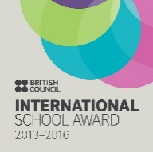
In November 2014, Annfield Plain Infant School was awarded the International School award. Due to the hard work of staff and children, the school completed a yearlong portfolio which included work on different cultures and the International Community.
We are proud to have the School Smoke Free Award, which was given to us in 2008. It shows that we educate our children concerning the consequences of smoking and we hope by doing so we can deter them from taking up the habit in the future. The school site is also smoke free, this includes the playground, footpaths and areas around the school gates.
Children, frequently, are not able to express their grief verbally. Rather it is reflected in their behaviour, academic performance, physical and emotional wellbeing. Rainbows is a training programme to support children in dealing with change and loss in their lives.
Ofsted’s View of Our School
Inspection 18th October 2018

· Leadership have provided strong, dedicated and astute leadership which has driven the continuous development of the school.
· A key strength of the school that has been maintained is the personal development and welfare of the pupils.
· Children starting in the reception class enter a caring, nurturing environment which helps them to develop their social skills and self-confidence.
· Parent View (Ofsted’s Parents Questionnaire) were overwhelming positive about our school and all would recommend the school to another parent.
· Many parents mention the caring and supporting ethos of the school, where the staff help children to learn and thrive.
· In early years, children are making at least good progress from their starting points and many are making rapid progress.
· Attainment is strong in Reading, Writing and Mathematics.
· Working with local schools helps to support transition and ensures continuity of learning when they move to their next school.

You can read the full report on www.ofsted.gov.uk
Or on the school website www.annfieldplain-inf.durham.sch.uk

.

School Organisation

Head Teacher | Mrs A Kane
Deputy Head Teacher | Mr M Urwin
School Administrative Officer | Mrs F Wright
Class Teachers | see page 6
HLTA | Miss A Hodkinson
Teaching Assistant | Mrs S Martin
Teaching Assistant | Mrs H Waters
Teaching Assistant | Miss J Curry
Caretaker | Mr C Liddle
Lunchtime  Supervisors | Miss L Blair
 | Mrs D Northey
 | Ms D Spencer
 | Mrs A Mallows
 | Miss E Guthrie
Catering Staff | Mrs D McGurk
 | Ms D Anderson
Cleaner | Ms D Spencer
Parent Support/EWO | Mr L Elsdon

School Organisation Continued
Our school provision is for 2 stages:

Foundation Stage - Reception (4-5 years old)

Key Stage 1 - Year 1 (5-6 years old)
Year 2 (6-7 years old)

Class organisation depends upon pupil numbers as no class is to exceed 30 pupils - this sometimes necessitates mixed age classes.

For the academic year 2021—2022 the school is organised in the following way:

Class 1
Reception
Mr Urwin
Miss Hodkinson

Class 2
Year 1
Mrs McGoay
Mrs Waters

Miss Curry
Supports all classes
Class 3
Year 2
Mrs Clayson
Mrs Martin

The School Governors
The school governors are like a board of directors and make decisions about how the school is run. They attend one meeting a term and these meetings are held in school. As well as being a member of the governing body school governors are also are members of a sub-committee.
Governors are appointed to help:
· Interview and select staff.
· Decide how the school budget is spent.
Mrs A Kane | Head Teacher
Mrs S Scott | Chair
Mrs H Dryden | Vice Chair
Mr M Urwin | Staff representative
Mrs D Northey | Parent
Mrs H Lolachi | Parent representative
Miss L Bainbridge | Parent representative
Mrs J Williams | Co-opted
Mrs J Stephenson | Local Authority Representative

Parent Governors:
· Are elected by the parents of the school.
· Serve, as other governors, for four years.

When a vacancy for a parent governor is available parents are informed and nomination forms sent out. For anyone interested becoming a school governor an information pack is available in school.

Training
New governors are encouraged to attend training to help them fulfil their role. A comprehensive range of training courses are run by Durham Local Education Authority.

School Routine
At Annfield Plain Infant School we are keen to encourage punctuality, which is an important habit for life.

School Hours
8.50 – 3.15pm

The school day begins at 8.50am and ends at 3.15pm.
The lunch break is taken from 12.00 pm to 1.15pm, depending on the year group. Each child gets 1 hour for lunch. During the school day there are two “playtime” breaks, one in the morning and one in the afternoon - both are flexible.
We wish all parents to understand that lateness affects your child’s education and disrupts that of the other children in your child’s class. We expect all children to be in school by 8.50 am. If your child is going to be late please bring him/her to school as soon as possible. Do not wait until the beginning of the next session. Children who frequently come to school late will receive a letter asking parents to address the issue immediately. We look forward to your support in this matter and in helping to maintain high standards and expectations in our school.
If your child needs to be absent from school for a medical appointment, please inform the school office in advance and provide evidence of this appointment. This may be an appointment letter or card.
In case of an accident or illness at school we will try to contact you, but in the meantime members of staff will take any necessary emergency action.
Telephone numbers and contact addresses will need to be listed on your child’s inventory form which will be completed at a pre-school visit.

Arriving and Leaving School
Children in years 1 and 2 come into school via the small gates and are welcomed by Mrs Kane the Headteacher and Mrs Martin, Teaching Assistant. They walk around the building and enter school by their cloakroom doors, where they will be met by a classroom assistant to support them in hanging up their coats etc.
Reception children will enter via the big school gates and will walk past the main office entrance and around the side of the building into the reception garden. They will be met by their class teacher or Teaching Assistant and taken into school.
In order to ensure a smooth start to the school day parents are requested to approach teachers at the end of the school day or contact the school office for an appointment, if a concern may take longer to discuss. Mrs Kane will be available each morning, for parents to pass on quick messages.
In the interest of security, the doors in the yard and gate will be locked at 9.00am. If your child is late you must report to the main entrance at the front of the building and sign the late book.
Year 1 and 2 children are dismissed by their class teacher at the front of school. If the parent/carer who is picking the children up at the end of the day is not there, the children are instructed to remain with their class teacher. It is very important that you, as parents, reinforce this. Reception children should be collected from the same door as the morning ‘drop off’.
Parents are requested to inform school if the usual routine is to be altered in any way, including if there is a different adult collecting your child on a certain school day.
For health and safety reasons parents/carers are requested not to allow children to deviate from the footpaths or climb school walls/fences.
As the road through Annfield Plain is very busy and dangerous, please teach your child to use the crossing area outside of the Junior school building. We practise kerb drill in school and would be grateful if you would help us in insisting upon your child following drill procedure whenever he/she wants to cross the road.
Visits are made to school by Road Safety Officers to reinforce this work.

School Meals
Meals are provided at school and a choice of main course and dessert are available. School meals are free to all children in reception and KS1. Dinner Menus are given to parents termly so they can see what is available to their child on a certain day. Children may bring a packed lunch to school but the office must be kept informed of changes to your child’s meal arrangements (We ask that a minimum of one week is given when a child is changing their lunch arrangements). We have a leaflet on advice for healthy packed lunches.
Medication
Both our school and the Junior School operate a common policy for the administration of medicines to children during the school day. Whist it is preferable for medication to be given at home, it is recognised that where medicines are prescribed to be taken three or more times a day, it may need to be administered in school. Staff in school will administer only prescribed medicines and the parent/guardian must complete an appropriate medication record form each time a course of treatment is brought to school. All medicines should be provided in the original container as dispensed by a pharmacist and include the prescriber’s instructions for administration and the child's name on the bottle/medication. Staff will keep a permanent record of each time medication is given to a child. Non-prescribed medication will not be administered by school staff.
The National Fruit & Vegetable Scheme
Children are offered a piece of fruit daily as a mid-morning snack. This is provided free as part of the Government’s School Fruit and Vegetable Scheme. The children are encouraged to try the variety of fruits offered as part of our Healthy School status. The scheme is voluntary and there is no obligation for your child to take part.
No other snacks or sweets are allowed in school to ensure that children with food allergies are not put at risk. Occasionally a class reward or treat may be given with teacher supervision.
Water
Access to water is essential to our pupil’s welfare. We ask that you send a bottle of water, (tap, filtered, or mineral but not flavoured) daily so that they can access this as part of their classroom routine. Please ensure that your child’s name is on the bottle. Bottles can be bought at the school office at a cost of £2.00.

Milk
Your child has the opportunity to have fresh milk in school on a daily basis. The milk is free to the under 5’s and available to the over 5’s at a cost of approximately £14.00 per term. For your child to receive milk, parents must register with Cool Milk at www.coolmilk.com

Complaints
The school hopes that parents will share concerns with Class Teachers, Deputy Head Teacher and the Head Teacher, where appropriate, in all cases.
Unresolved queries should also be brought to the attention of the Governing Body of the school. Parents may also contact Michael Tallentire, Directions operator of the Stanley Learning Partnership. Information is on the school website.

Breakfast Club
Breakfast club runs each school day morning from 8am—8.50am. It costs £1.50 per session, payable in advance. Children can participate all week or attend individual sessions. The children do lots of fun activities including colouring, games, cooking etc. The children also get a choice of cereal for breakfast as well as toast and a drink.

Wraparound Care
Wrap around care runs each school day afternoon from 3.15pm to 5pm. It costs £4 per session and is payable in advance. Children can participate all week or attend individual sessions. The children do lots of fun activities and have a healthy snack and drink.

School Fund
We ask each family to make a small voluntary contribution each week.
This money helps with many pleasurable things such as Christmas Festivities and Theatre Groups visiting school.

Money
All money for school should be presented in a named envelope or purse with a note to say what the money is for e.g. school fund, trip money, etc.

Clothing
Please name ALL your child’s clothing and footwear. A peg to clip together Wellingtons, and gloves taped through coat sleeves are good ways to prevent loss or mix up. Sandshoes, t-shirt and shorts will be needed for outdoor PE.
The school uniform colours are purple for sweatshirts, pullovers, cardigans etc, worn with grey/black trousers, skirts or pinafore dresses. In summer grey/black shorts, white t-shirts or purple/lilac gingham dresses. Items bearing the school logo may be ordered from school or on-line directly with our supplier. This dress code also includes appropriate hair styles—i.e. no symbols or pictures, hair extensions or vibrant colours. Shoes/boots should be of a sensible height to ensure safety in school.

Extra curricular activities and visits
We aim to offer a range of extra-curricular experiences across the school such as football, visits out and visitors into school, e.g. theatre groups, musicians.

Educational visits are often arranged to support the studies that are taking place in the classroom. Each visit is carefully planned and organised to provide a valuable learning experience. Parents are usually invited to make a voluntary contribution towards the cost of the visit, which is often subsidised through school funds. A child will not be prevented from taking part in a visit on the basis that he/she has not contributed. However, the school reserves the right to cancel a visit if it is not financially viable.

The school reserves the right to exclude any child from a visit if his/her behaviour is not supportive of health and safety issues.

We offer a variety of after school activities that the children have an opportunity to join. This year we offer Rugby, Dance, Cheerleading, Strength Work, Multiskills, Football, Gymnastics and dodgeball..

School Benevolent Fund
If a parent is a recipient of Income Support, Income based job seekers allowance or child tax credit (annual household income lower than £16,190 and NOT in receipt of Working Tax Credit) then you could be entitled to receive money to help with the cost of a winter coat and a pair of shoes for your child. You must be a resident of County Durham to receive the entitlement of £35 per each item. Application forms for the School Benevolent Fund are available from the School Office. Parents must apply independently to Durham County Benevolent Fund c/o Thornhill Primary School.

Arrangements for Admissions and Induction
Children starting school for the first time are admitted during the school year in which their fifth birthday falls. Children must have their fifth birthday between 1st September and 31st August inclusive of the year in which they begin school.
Durham LA’s admission policy applies and children are admitted in September. The school’s admission number is 40.
Pre-school visiting days for parents and children are arranged for the term prior to admittance. This helps the children to feel at ease and to settle into school more readily. Parents are welcome to look around the school prior to submitting a preference form.
Transfer to and from other Schools
Parents moving into or out of the area should notify the Head Teacher as soon as possible so that arrangements can be made for the transfer of children’s records and books to their new school. Due to new County Council policy, the Admissions Team in County Hall now hold responsibility for all children’s transfers. Parents should therefore fill out the appropriate transfer-request from (available on line at the County website) and return to Durham County Hall Admissions Team.

At the end of year 2 many children from Annfield Plain Infant School transfer to Annfield Plain Junior School. During the final term several activities are organised for our children in year 2. These involve children working with the staff from the junior school on art/music projects, regular visits and meetings with their buddies from year 5. These visits enable the children to become familiar with the junior building and helps them to get to know the staff and children before they start in September. This will help make the transfer to the junior school as easy and successful as possible.

Children in reception and Year 1 will also have the opportunity to visit their new teacher and class during the Summer Term. They will spend each morning, for a week doing activities and learning the new routines ready for September.

School Attendance

At Annfield Plain Infant School we try to ensure good attendance. If your child is unable to attend school for some reason then you should inform us on the first day of absence no later than 9.30 a.m.

You can notify us: in writing, by telephone (01207) 234 691, by email at annfieldplaininfant@durhamlearning.net or in person.
The information we require is as follows:
· Name of your child
· Name of your child’s class teacher
· Reason for your child’s absence
· Likely date of return, if known

Valid reasons for absence are:
· Illness
· Attendance at a medical examination/consultation
· Attendance at dental appointment
· Attendance at speech therapy session.

*Please bring a copy of your child’s appointment letter/card to the school office
*School Policy indicates that if no reason of absence is provided by the parent before 9.30am on the day of the absence then the School Administrative Officer will contact parents.

If your child is absent for more than seven school days then you should expect a visit from the Educational Welfare Officer (EWO) as a matter of course. If the school is concerned about a pattern of attendance then we will request that the Educational Welfare Officer visits your home. From September 2015 in accordance with new government guidelines, children with an attendance of less than 96% will be monitored by the EWO.

Authorised leave may be granted, after consultation with the Head Teacher, but only in exceptional circumstances will up to 5 days be granted.

If you require leave of absence for a particular occasion or reason, authorisation should be sought in advance of the occasion. A letter should be written to the Headteacher/Chair of Governors. Each case will be considered on its own merits.

A copy of County Guidelines on Attendance is available at the school office.

If for some reason the school does not receive notification of absence you will be asked to complete an “explanation of absence” form when your child returns to school. If you fail to do so your child’s absence will be recorded as an
‘Unauthorised Absence’ and will follow your child throughout their schooling.

Attendance figures for the academic year 2021/2022 are presented in a table below.

Year  Group | Number on register on  1.9.21 | Number of possible  attendances | Number of actual  attendances | %  attendance | %  Authorised absence | %  Unauthorised  absence
Reception | 26 | 8788 | 8180 | 93.52 | 6.28 | 0.20
Year 1 | 32 | 10752 | 10041 | 93.71 | 5.98 | 0.31
Year 2 | 24 | 8211 | 7610 | 94.77 | 4.60 | 0.63
School | 82 | 27751 | 25831 | 93.96 | 5.67 | 0.37

School Holidays 2022/2023

Holiday | Closing Date  (At the end of the school day) | School re-opens for Teaching
Summer Holidays 2022 | Thursday 21st July 2022 | Tuesday 6th September 2022
Staff Training Day 2022 | Thursday 30th September 2022 | Monday 3rd October 2022
Autumn Half Term 2022 | Friday 21st October 2022 | Monday 31st October 2022
Christmas Holidays 2022 | Tuesday 20th December 2022 | Wednesday 4th January 2023
Spring Half Term 2023 | Friday 17th February 2023 | Tuesday 28th February 2023
Easter Holidays 2023 | Friday 31st March 2023 | Monday 17th April 2023
May Day 2023 | Friday 28th April 2023 | Tuesday 2nd May 2023
Summer Half Term 2023 | Thursday 25th May 2023 | Monday 5th June 2023
Summer Holidays 2023 | Friday 21st July 2023 | Monday 4th September 2023  (To be confirmed)

The Foundation Stage - Reception
The curriculum for the children in reception is broken down into seven areas of learning:

3 Prime Areas:
· Personal, Social and Emotional Development
· Communication and Language
· Physical Development

4 Specific Areas:
· Mathematics
· Literacy
· Understanding of the World
· Physical Development

The reception year is intended to be a comfortable bridge between the nursery regime children are familiar with and the more formal structured environment of school. The Foundation Stage provides a broad-based curriculum, based on the Early Learning Goals, which set out what most children are expected to achieve by the end of the year.

Great emphasis is placed upon communication and personal, social and emotional development, as these underpin everything else which is taught. Play is
acknowledged as an important way to develop independence, confidence, self-worth and an understanding of others.
Children in reception also currently follow the Early Years Foundation Stage Framework and this is always appropriate to their age and stage of development. The
Foundation Stage ends at the end of Reception year, when the majority of
children will be ready to move on to year one of the National Curriculum.
Read, Write Inc is used for the teaching of phonics, reading and writing throughout school.

Key Stage 1
The children in year 1 and year 2 follow the National Curriculum which consists of the following areas:

Our Vision for English
Our curriculum is designed to allow our children to be enthusiastic and confident communicators, readers and writers. We aim to ensure that all children have a strong self-belief that they ‘can do’ and that anything is possible and everything is achievable

The Spoken Language: - The entire curriculum for English is underpinned with a commitment to develop our children’s abilities in spoken language and listening skills. We aim to provide a nurturing environment where all opinions are valued and that everyone has a voice. We will ensure that our children speak clearly and confidently in a range of contexts.

Reading: - We will strive to ensure that we develop, in our children, a true passion for books and reading. Read, Write Inc is the scheme used so that our children will be able to apply accurate and speedy word reading skills. Our carefully chosen books will inspire, excite and set free imaginations. We will ensure that our children will broaden their vocabulary and make connections by listening to and reading relevant non- fiction texts.

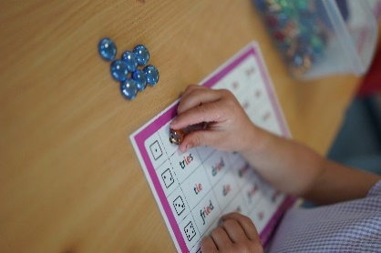
Mathematics
The mathematics curriculum aims to equip the children with the mathematical concepts and skills relevant to the world they live in. This includes the ability to solve problems, understand numbers, shapes and relationships, predicting likely results. We use a wide variety of resources, including Numicon, to help us deliver the mathematics in school.

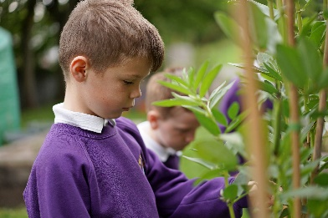
Our Vision for Science
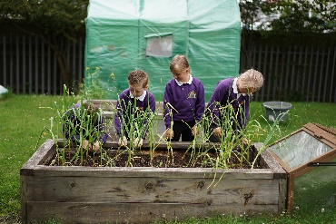
Our curriculum is designed to provide our children with an increasing knowledge and understanding of the world around them. We will encourage the children to be curious, inquisitive and excited about science. Through practical, hands on experiences children will be encouraged to explain what is happening, predict how things will behave and analyse the causes. Our children will develop a high level of scientific vocabulary and they will be challenged to ask and answer questions. We are committed to enabling our children to experience and observe phenomena and look more closely at their environment to develop an understanding of the challenges that scientists face today. We want our children to make links between science and the real world and understand the role that they have to play. We are committed to offering our children a curriculum which helps them to understand that famous scientists, both male and female were once children just like them and that they could be famous scientists too!

Our Vision for Computing
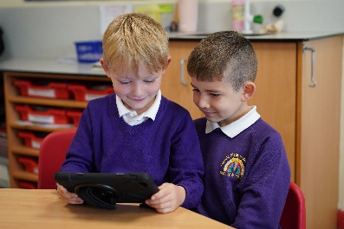
Our curriculum is designed to provide our children with the skills to use computational thinking and creativity to understand and change the world. We will teach our children key knowledge and skills of computer science, IT and digital literacy. With technology playing such a significant role in society today, we believe that children need these skills if they are to be able to participate effectively and safely in the ever-changing digital world. We aim to deliver a curriculum from which children are equipped to use information technology purposefully as well as ensuring that children become digitally literate for their future in the workplace. We want our children to become safe, independent and creative users of technology so that they are prepared for their future in a digital world.

E—Safety
As part of our computing curriculum the children learn to stay safe on the internet. Through E-safety the children learn how to use technology safely and respectfully. They learn about keeping their personal information private and who they can go to for help.

Our vision for History
Our curriculum is designed to provide a coherent and chronological knowledge about the past. It will inspire in pupils a curiosity and desire to find out more about the past and will equip children with the skills to develop critical thinking, ask perceptive questions and to begin to make their own judgements using the variety of evidence presented to them. We are committed to helping our children develop their own sense of identity and understand their local heritage. We are passionate that children will learn to value events of the past and begin to see how they have helped shape the world we live in today. We are dedicated to ensuring pupils make connections between history and other subjects, particularly technology, music and art. History is a subject where we love to get out and about and explore changes both in the local area and through a range of visits.

Our vision for Geography
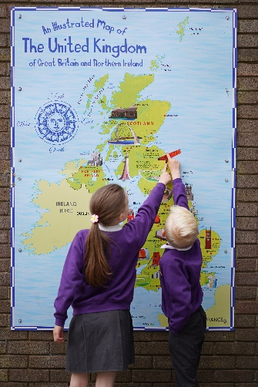
Our curriculum is designed to inspire in pupils a curiosity and fascination about the world and its people that will remain with them for the rest of their lives. We will equip our children with the knowledge about diverse places, people, resources and natural and human environments. Our children will learn about human and physical processes and the interaction between them. We are passionate about showing children current, real world applications of geography and by doing so we believe we will open up a range of possibilities which will raise their aspirations for the future. We are dedicated to ensuring pupils make connections between geography and other subjects, particularly science and maths. We are determined our children will be proud of and respectful for their local area, knowing that they can become active citizens within it. There will be a large focus on fieldwork in many units of study. We are passionate about helping children understand that they are custodians of the earth and will encourage them to protect and shape it for future generations.

Physical Education
We aim to ensure that our children have the opportunity to acquire basic sports skills, physical fitness and co-ordination. We aim to offer two hours per week of PE lesson time through which we develop areas of activity set out in the National Curriculum - games, gymnastics and dance. We also have coaches

Our Vision for Art
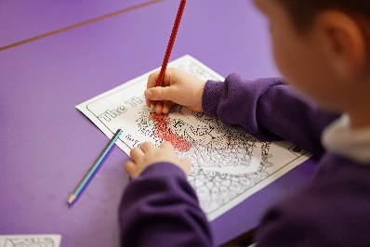
Our curriculum is designed to engage, inspire and allow our children to be confident in their own creativity. We will provide experiences and opportunities for our children to build upon knowledge and skills so that they can create their own works of art, craft and design. We are committed to providing a curriculum that celebrates great artists, craft makers and designers, including local artists, which have shaped our past and influence our present. Through our teaching of Art, we aim to instil and nurture a strong sense of self belief that, they too, can influence and shape the future.

Our Vision for Design and Technology
Our curriculum is designed to allow our children to use their creativity and imagination to design and make products that are contextually real and relevant.
We will enable our children to develop a sense of curiosity about how things work and a recognition that societies needs are forever changing. We will provide a curriculum that will support and guide our children through the designing and making processes. We will ensure that they have the confidence and opportunity to follow their own ideas and support them in becoming resilient, positive, resourceful and innovative young people.

Our Vision for Music
Our Music curriculum is designed to enable each child the opportunity to appreciate and enjoy music in all of its different forms. We will encourage children to reach their full potential in Music. We will provide opportunities to listen to a wide variety of musical genres, including live music and local musicians. Children will be encouraged to sing, compose and perform. We believe performing is an important part of music and therefore children will be given the opportunity to perform in front of an audience both within and outside of school. We are dedicated to exploring with children the power music can have by bringing together people and communities. Music is a positive outlet for children to express their emotions and explore their creativity. Throughout the year, we will celebrate the importance music plays in local and national festivals.

PSHE and Citizenship
In PSHE and Citizenship the children develop knowledge and understanding of themselves, their relationship and the society in which they live. PSHE helps the children to build their confidence, resilience and self-esteem and to identify and manage risk, making informed choices. In PSHE and Citizenship we provide opportunities for the children to develop the skills they need to lead confident, healthy, independent lives and become informed, active and responsible citizens.

Our Vision for R.E.
Our R.E. curriculum is designed to allow our children opportunities to explore different religious beliefs, values and traditions. We will enable children to
develop an understanding and awareness of the numerous religious traditions, beliefs and practices that are followed in our multi-cultural society. We will, in a supportive environment, encourage children to ask questions about the world and to reflect on their own personal experiences, values and beliefs. Through all of this, our children will develop and grow, becoming independent, tolerant, respectful and responsible members of society.

Spiritual, Moral, Social and Cultural Development
We help children to develop a sense of awe and wonder. We talk about right and wrong, fairness and respect. We help children learn how to get along with each other and feel part of their community. We help children understand their heritage and appreciate and accept that of others.

An opportunity to see us at work and play!
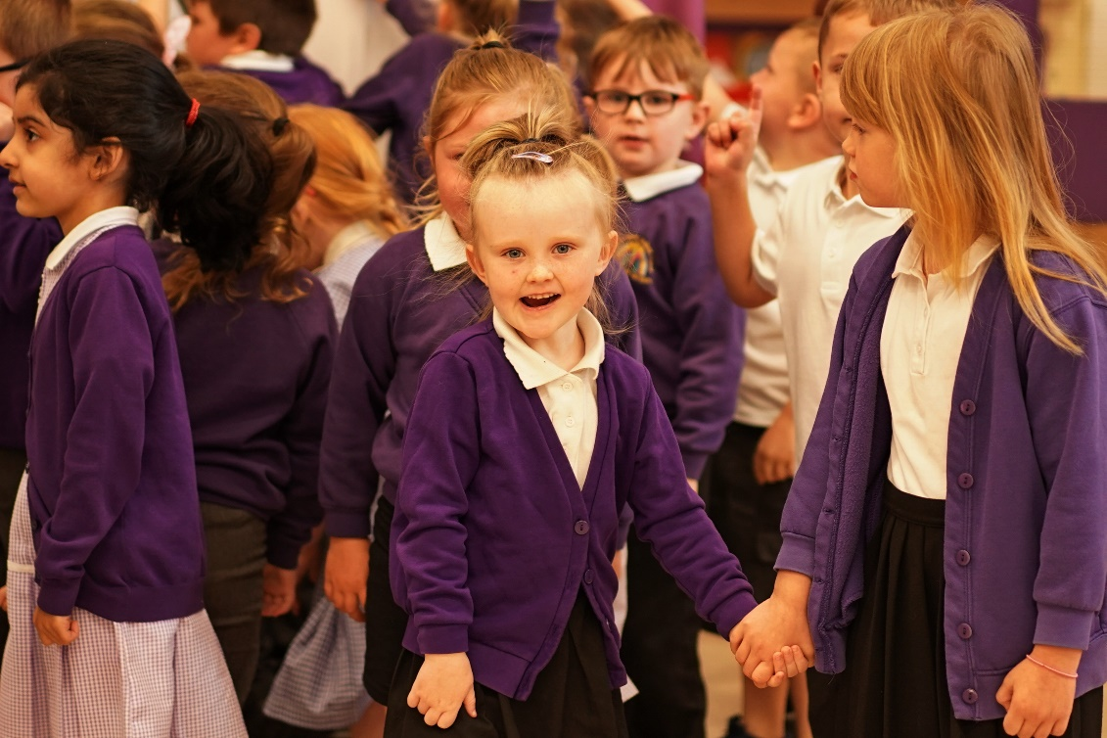

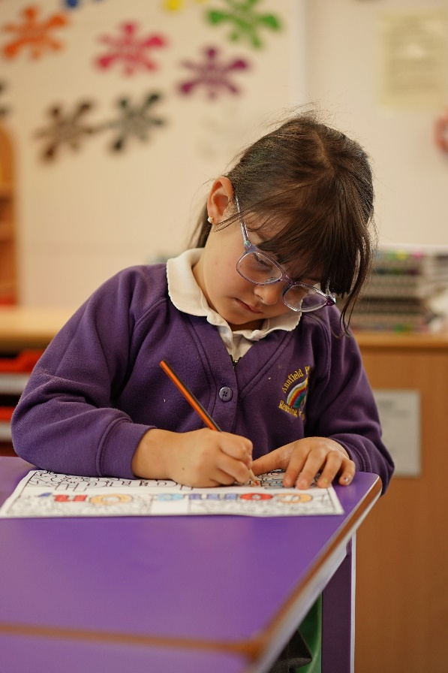

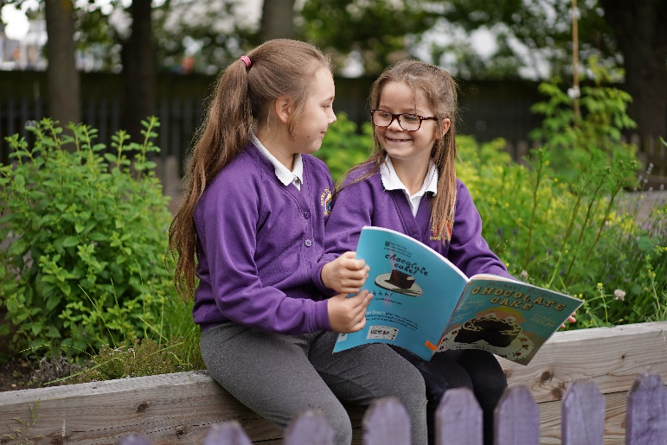

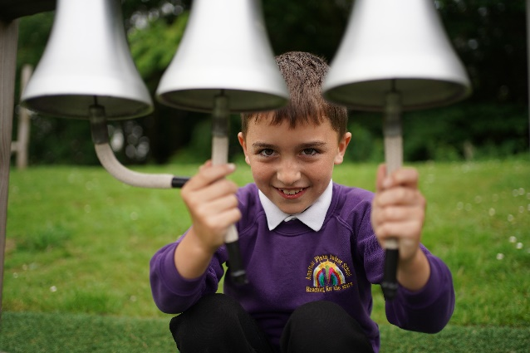
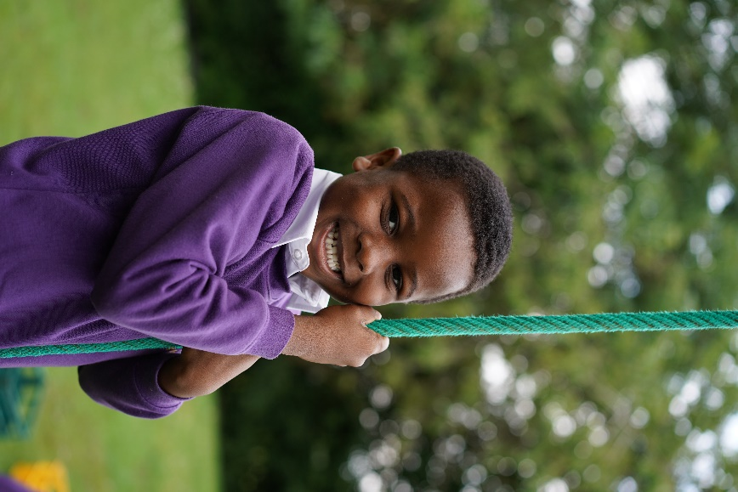

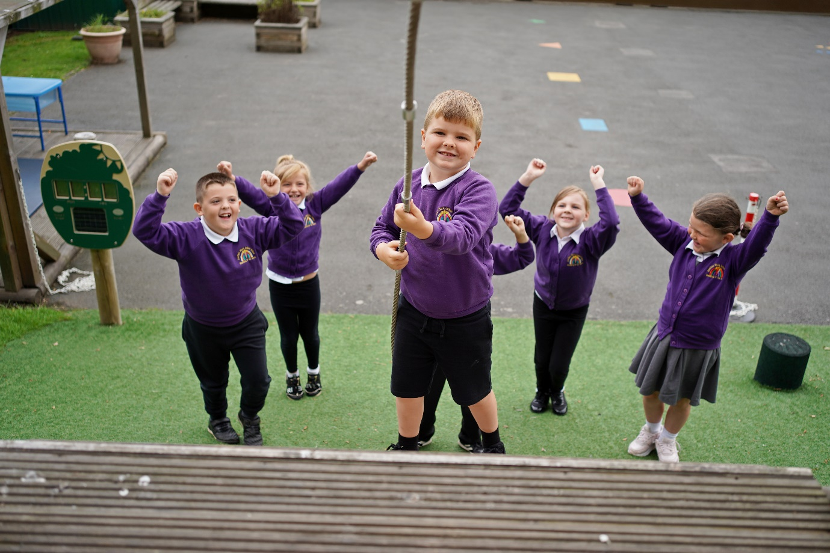

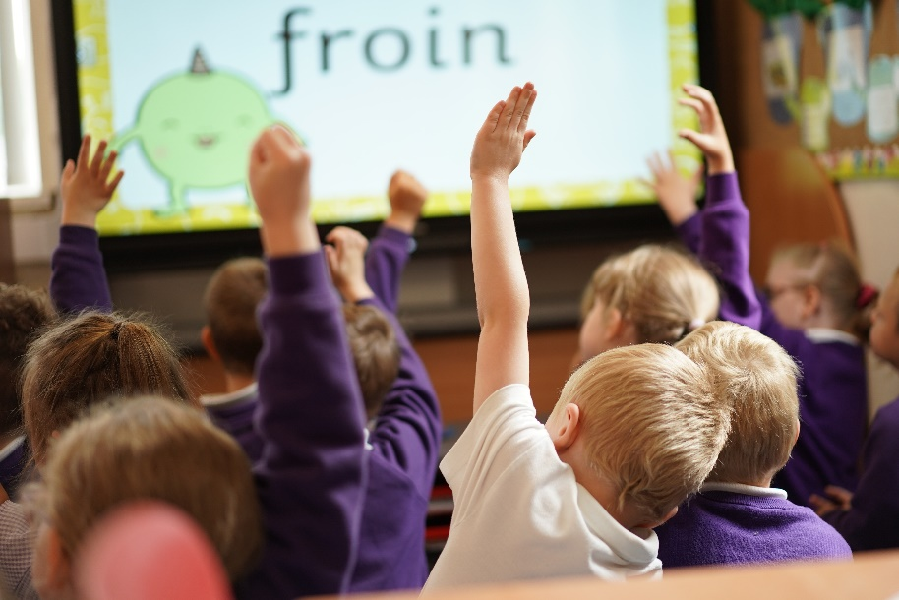

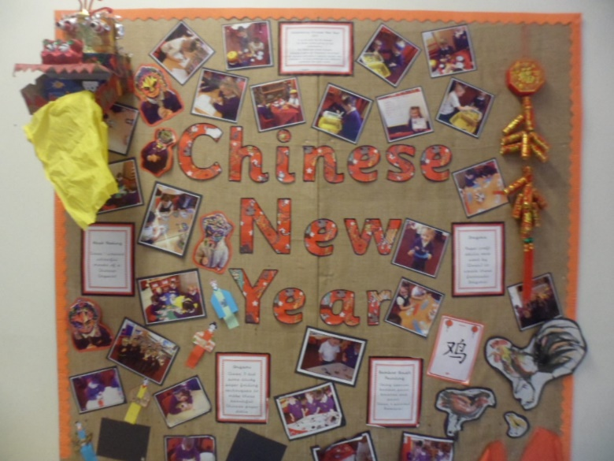
We enjoy celebrating different festivals and learning about different cultures. This year we have celebrated Chinese New Year.

British Values
We promote the British Values of
· Democracy
· The Rules of Law
· Individual Liberty

Collective Worship
In our school we conduct a daily act of Collective Worship. This is organised and led by staff and visitors. All parents have the right to withdraw their children from Collective Worship. If you wish to withdraw your child please contact the Head Teacher.

Relationships and Sex Education
In our school we follow a relationships and sex education programme called Lucinda and Godfrey which enables children to make informed, healthy decisions and stay safe. Any questions are answered simply as they arise and aspects of the subject may be covered in connection with topics such as pets and ourselves etc.

Multicultural Education
To reflect the society in which we live and so our children know about, understand and respect each and people of other cultures, our multicultural society is reflected throughout the curriculum, equipment and books used.

Equal Opportunities
All forms of education and training are equally accessible to all pupils to encourage them to develop their aptitude to the full.

Year 1
Children in year 1 follow the guidelines set out in the National Curriculum. The work is always appropriate to the child’s age and stage of development. The children will sit a phonics test in the month of June.

Year 2
Children in year 2 will follow guidelines set out in the National Curriculum. In year 2 the children are subject to national procedures for SATS which involves a combination of ongoing teacher assessment and test materials. These are done in the month of May. Children who didn’t reach the expected level in their phonics test in Yr1 will have the opportunity to resit again in Yr2, during the month of June. End of year teacher assessments are reported to parents in the children’s annual school report.

Nurture Group—The Seedlings
Nurture Group is a small group of children and staff who work together for three afternoons a week. Nurture provides a safe, predictable and structured learning environment. It gives the children opportunities to access experiences which support their development of language, communication skills and a focus on social, emotional and challenging behaviour.

Special Educational Needs
Many children need varying forms of special help. Children with Special
Educational Needs are dealt with according to individual requirements. The early identification of specific needs is essential so that early intervention can take place. Children are then placed on the special needs register.

Within ‘Short Notes’ stage pupils may be given:
· Tasks at their level of understanding
· Help from a school based adult, either teaching or non-teaching
· Small group and individual work

At ’Support Plan’ stage additional help and support may be sought from other agencies such as:
· Learning Support Service
· Speech Therapy
· Occupational and Physiotherapy
· Education Psychology Service
· Child Health

Parents are always consulted when a special need is identified and kept
informed about their child’s progress. If a child has an Educational Health Care Plan their arrangements are reviewed annually.

There is a Parent Partnership for Special Educational Needs based at County Hall, which is call SEND iass (Special Education Needs and Disability Information, Advice and Support Service). Durham telephone (0191) 5873541, 03000 267007 or email sendiass@durham.gov.uk. Information can also be found on their website: www.durhamsendiass.info Information on the Local Offer is available on the school website.
Parent Support Advisor
The school EWO is Mr Elsdon. He can be contacted on:07787 057938

He offers early intervention for concerns no matter how small, which can alleviate worries, stop problems from growing or re-occurring. He will also signpost to appropriate services if needed. He monitors school attendance and will work with families to get children into school. The service is kept confidential.

Safety

School Travel Plan
· We ask parents to be aware of issues around safe arrival and departure from our school.
· Reduce parking in and around the roads directly adjacent to the school at the start and finish of the school day.
· To keep the children away from vehicles.
· To encourage walking to school and Park and Stride to school as a healthy choice.
· We encourage active participation in Walk to School initiatives and would like as many parents as possible to make a pledge to Park and Stride.
· Please do not park on the lines outside school—this is for the safety of all our children.
· Durham County Council now employ Traffic wardens to visit schools in the county and will issue on the spot fines to owners of cars parked illegally.

Dogs
Dogs are not allowed onto the school premises.

Smoking/ECigarettes
Smoking or the use of E-cigarettes is not allowed in the school grounds or at our school gates.

Little Ears
Our children in and around school are very young so please consider this when chatting to friends at the school gates. Some parents use language that other parents find offensive and inappropriate for our young children to hear. We do not allow children in school to use inappropriate language and parents will be contacted if this is witnessed.

Sweets, crisps & pop should not be consumed on the school yard before or after school

Homework

As a parent you can provide a great deal of support by encouraging your child to discuss work at home, by talking and reading together and at times by helping with the collection of materials or information for work in school.

Reading books are brought home for the evening. In this way you can keep abreast of the progress your child is making, as well as provide help and encouragement. Library books are also available in school for your child to borrow.

A home spelling programme is also encouraged to assist children in acquiring the basic spelling rules. Simple maths tasks are also set to reinforce the work within the class.

The school expects homework and reading books to be returned by a specific day. Class teachers will notify you of the homework timetable which is relevant to the class your child is in.

Please remember that your child will have worked hard in school and also needs time to play, take up hobbies and socialise with other children. If we are to
develop the child these areas must not be neglected.

Pupil Premium - The Pupil Premium was introduced in April 2011 which meant schools were allocated funding for children from low income families who were eligible for free school meals, looked after children, and those from families with parents in the Armed Forces. Further information can be found on our school website.

Sports Premium - The Government provides annual funding for sporting activities. This funding is being jointly provided by the Departments for Education, Health and Culture Media and Sport, and will see money going directly to primary school head teachers to spend on improving the quality of sport and PE for all their children. The sports funding can only be spent on sport and PE provision in schools. Further information can be found on our school website.

Assessment and Reporting to Parents

Assessment is an integral part of the teaching and learning process and is the tool which aids planning of work for children.

Alongside the continual teacher assessments, the children have more formal
assessments which occur each year throughout their school life.

Reception
· Baseline Assessment
· Language Link—Autumn 1/2 term.
· End of Year Assessment - summer term.

Year 1
· Phonics test is administered in the second half of the summer term.

Year 2
· SAT’s in the month of May. A combination of teacher assessment and test materials.
· Phonics, retest for those children who didn't pass in year 1 in June.

The resulting end of year teacher assessments are given with the yearly report which you will receive towards the end of the summer term.

You are invited into school to discuss your child’s progress at various times
during the year, either through an appointment or on an open evening. You are welcome at any reasonable time, to see either your child’s class teacher or the Head Teacher. Arrangements for specific appointments can be made by calling in at the office or telephoning the school.

During the year the school holds:
· Open Evening - October/November.
· Open Evening – Feb/March.

As a parent you will receive a yearly written report about your child’s progress towards the end of the summer term.

See the appendix for information about our school SAT results for the
academic year 2018/19 and how they compare against national SAT
performance results.

Behaviour
Our aim is that an atmosphere of good discipline should prevail which is based on a clear understanding between pupils, staff and parents of what constitutes an acceptable code of behaviour. This does not mean an atmosphere of unquestioning regimentation, but behaviour which is based on self-awareness.

We believe that young children respond better to praise than to criticism. Therefore, we aim to notice the well-behaved children and provide rewards for good behaviour. By noticing the well-behaved children, we hope to develop a positive atmosphere which is pleasant for teacher and pupil to work in and which encourages all children to follow suit.

Rewards for good behaviour include:
Stars
Certificates
Stickers
Hat bands
Reward Afternoon

Aims and Expectations
We would like to provide a calm, safe environment in which all pupils can achieve their very best.

We would like to raise children’s self-esteem and help them to have confidence in themselves.

We would like the children in our care to be happy, confident and secure.

We would like the adults in our school to be kind, caring and considerate and to be good role models for the children to follow.

The School’s Approach
In the belief that our school should be a happy, secure place for all, we pursue a positive approach to good behaviour, encouraging children to conduct themselves in a responsible, self-disciplined manner and to care about the needs and rights of others. Intrinsic to this approach is the additional belief that parents, children and staff are all involved in a home/school partnership.

Rights Respecting School Award
We are very proud to say that Annfield Plain Infant School are the holders of the Rights Respecting Gold Award, which we received in the summer of 2021.

The Rights Respecting Schools Award (RRSA) is based around the United Nations Convention of the Rights of the Child. It will help form a moral code within school and will allow the children to develop a clear understanding of their rights but also their responsibilities within the school and their local and global community.

The Rights Respecting Schools Award recognises achievement in putting the United Nation’s Convention on the Rights of the Child at the heart of school’s planning, policies, practice and ethos. As a rights respecting school we will not only teach about children’s rights but we will also model rights and respect in all our relationships: between teachers/adults and pupils, between adults and between pupils.

Charters
At the beginning of each year, classes negotiate a class charter. This relates to our PSHCE policy and the United Nations Convention on the Rights of the Child. The children, with the help of their teacher, decide on the Rights and Responsibilities that they believe will make for a happy, hardworking environment where effective learning can take place. Once the Charter has been agreed, it is displayed in the classroom, and will be reinforced in day to day contexts by all adults in the school. If a child fails to follow the charter, they are reminded of the part they played in its creation and the commitment they made to it.

There is a charter for playtimes and a Staff Charter devised by the children. These charters are displayed prominently around school and will be reviewed from time to time by the children and staff.

Role of Governors
The legal responsibility for the discipline of the school lies with the governors who have delegated the day to day management to the Head Teacher.

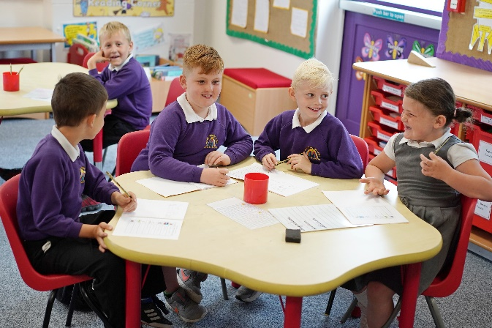

Role of the Head Teacher

It is the responsibility of the Head Teacher to implement the school behaviour policy consistently throughout the school and to report to Governors when requested, on the effectiveness of the policy. It is also the responsibility of the Head Teacher to ensure the health, safety and welfare of all the children in the school. The Head Teacher supports the staff by setting the standards of behaviour and by supporting the staff in the implementation of the policy.

Role of Staff

Class teachers have day-to-day responsibility for the behaviour of the children in their classes. A caring classroom atmosphere helps to reinforce good behaviour and teachers themselves are expected to be good role models for the children in their classes. Teaching and support staff share the responsibility for the sensible behaviour of the children in and around the school.
The lunchtime supervisors are responsible for the behaviour of the children over lunchtime and they follow the guidelines of Annfield Plain Infant School behaviour policy.

Role of the Parents

A Home-School Agreement will be provided for all incoming pupils on their arrival at the school and both parents and children are encouraged to read it and sign a declaration that they agree to it. Parents are made aware of the school’s policy and procedures at the induction meetings for parents and from the school brochure and via the communications between home and school. We look to our parents to make their children aware of appropriate behaviour in all situations and to encourage in them independence and self-discipline. Above all we regard good relationships between the parents and school of vital importance and actively encourage the parents to show an interest in what their child does there.

Role of the Children

Children are expected to follow the rules in the school and classroom and show respect for the rights and needs of everybody in the school community both adult and child. Good behaviour, politeness and good manners are insisted upon, especially when dealing with teaching staff; all support staff and other adults who may be in the school.

Education is more effective when there are close links and co-operation between home and school. As a school we feel that it is vitally important to develop these links and positively encourage parental involvement in all aspects of school life. We do this in a number of ways:

· Parent’s Evenings
· Christmas and Class assemblies
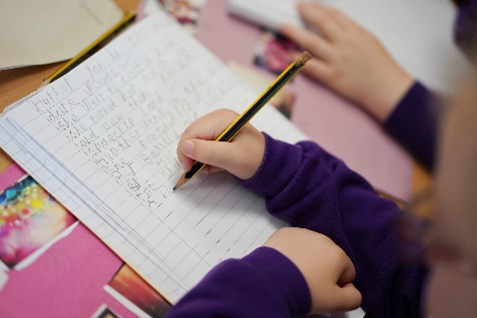
· Newsletters
· Curriculum events
· Home/school reading records
· Homework
· Information leaflets for reading and number work
· Letters & Sounds Booklets
· Website: www.annfieldplain-inf.durham.sch.uk
· Facebook Page: Annfield Plain Infant School
· Twitter: AnnfieldPlainIn

We welcome parents into school as helpers. You, as a parent can help with a range of classroom activities - changing library books, working with small groups of children and a variety of other activities. If you are interested in becoming a parent helper in school please contact Mrs Kane or Mrs Wright.

Community Links

At Annfield Plain Infant School we have good links with the local community.
· In school the children are visited by the Fire Brigade, Community Police Officer and school nurse.
· As part of the school curriculum the children visit the local churches.
· Children visit Tesco and see the warehouse, buy food and sing.
· Children visit our Junior School frequently and we have an annual ‘Singing Picnic’.
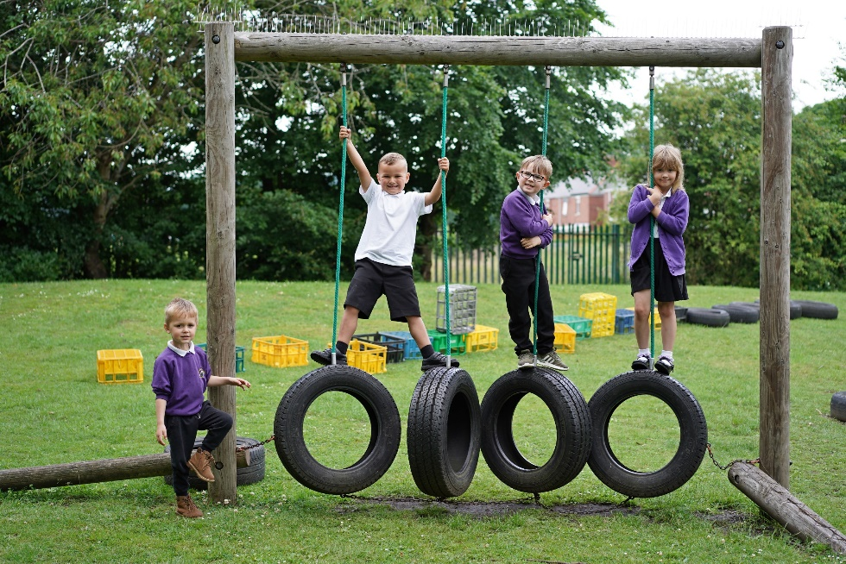

What school documents are made available for parents?

How can you find out what is happening in school? One way if you can’t come in and visit us is to read all about it. As soon as any major changes take place in the school curriculum we will inform you.

We encourage you to read the following:
· The School Brochure.
• Our school website – http://annfieldplain-inf.durham.sch.uk
· The School Profile.
· The latest OFSTED Report. (October 2018)
· Details of the school’s complaints procedure.
· The school’s policies, schemes of work and timetables.
· The Durham Agreed Syllabus for Religious Education.
· School Improvement Plan.
Some of the above are sent to you. The other bulkier documents are kept in school or on the school website. Parents are provided with a free copy of the School Brochure. If you would like to read any of these documents please contact the Head Teacher.

We have a Facebook page which is updated regularly. This page is for information only and not for leaving comments or asking questions. We also, now have, a Twitter account. Updates are provided several times a day.
@AnnfieldPlainin—Our Twitter Handle.

Please ring or call into the school office for any enquiries.

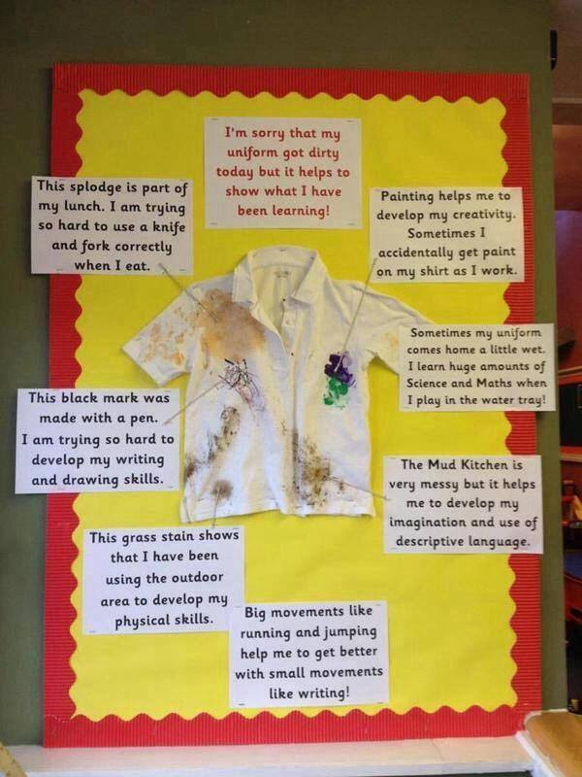

Greenland Community Primary School is proud to be part of Stanley Learning Partnership LTD (Trading as Stanley Learning Partnership)
Registered office:
Unit G3 Tanfield Lea Business Centre,
Tanfield Lea North Industrial Estate,
Stanley,
Co Durham,
DH9 9DB

Company number: 10380011 (Registered in England & Wales)

